AIPM Election Policy
Australian Company Number (ACN): 001 443 303
Australian Business Number (ABN):49 001 443 303 A company limited by guarantee

Version/ Amendment No | Date | Nature of Version/Amendment
Version 0.1 | 04/01/2022 | Initial Draft Election Policy
Version 0.2 | 17/01/2022 | V2 – reviewed by Simon Kaleski on 17.01.2022
Version 0.3 | 31/01/2022 | V3 – amendments of 17/01/2022 version
Version 0.4 | 25/02/2022 | Final

Table of Contents

1. Background 3
2. Definitions 3
3. Election Process 4
4. Chapter Council Elections 4
5. Member Elected Board Elections 10

Background

The purpose of this document is to define the process of the conduct of elections for Chapter Council and Member Elected Director elections.

Definitions

In this document, unless a contrary intention appears:

- "Board" means the Board of Directors of AIPM as defined in the AIPM Constitution 2020.
- "Chapter Council” means a Chapter formed by the AIPM Board.
- "Chapter Office Bearers", in relation to a Chapter, means the persons so described in this policy.
- "Chief Executive Officer" means the person so appointed under the Constitution.
- "Governance and Ethics Committee" is a Board Committee that provides guidance to the Board on matters including AIPM Governance, member codes of conduct and administration and discharge of any related disciplinary actions.
- "Nominations and Remuneration Committee" is a Board Committee that provides guidance to the Board on matters including reviewing nominations for Member Elected Directors.
- "Member" means member of the Institute of any grade or classification.
- "Grade" means the grade of membership of the Institute.

Election Process

The Governance & Ethics Committee is the Board Committee which has overall oversight over the Chapter election process.

The CEO is the ultimate decision-making authority and may delegate anyone to act on his/her behalf in all matters relating to the Chapter election and nomination process.

Selection of Election Company

In May or June of the year in which elections are to be held, the National Office should begin the process of identifying and selecting an appropriate third-party election company to conduct the annual elections. The selected Election Company should be able to conduct elections for both Chapter Councils and member-elected Director, if required.

The Australian Election Company www.austelect.com has been conducting elections on behalf of the AIPM for the last several years. A couple of alternative companies are Vero Voting www.verovoting.com.au and CorpVote Pty Ltd www.corpvote.com.au all of whom are registered Australian election companies.

The selected election company will be responsible for the conduct of the election including sending out to all members advice regarding the conduct of any election including ballot papers and instructions on how to cast votes as well as correlating the results of the elections.

Chapter Council Elections

The Returning Officer will be responsible for the conduct of the nominations process leading up to an election.

Retirement of Members

The Returning Officer will audit the current Chapters with a view to determining who is eligible to re-nominate for a position on Chapter Council by applying the Retiring Member rule as outlined below. Note that one third of elected members of a Chapter Council are expected to retire each year.

      - Those Councillors who have indicated they wish to voluntarily retire or wish not to seek re-election;

      - Those Councillors who have been appointed to fill a casual vacancy that year. (Casual Councillors must retire each year but may stand for re- election immediately upon retirement)

      - All Councillors who have served the maximum of two terms (six years). These members are unable to re-nominate until a period of three years has lapsed and then they may renominate for another single term (I.e. ,3 years duration) only.

      - Councillors who have already served a single term (ie one full three year term), may stand for re-election immediately upon retirement if they choose to do so;

    - if required each Councillor who has been longest in office since their last election must retire, until the minimum number of Retiring Members has been reached ie one third.

      - If there are two or more people who became members of the Chapter Council on the same day, those to retire shall (unless they otherwise agree among themselves) be determined by lot.

      - Where the total number of Councillors who have been appointed to fill a casual vacancy, plus those who have served a full three-year term plus those who have served the maximum of three years, equals or exceeds the minimum number of Retiring Members, each of those members must retire and may stand for re-election immediately upon retirement. In this instance, no additional members will be required to retire.

- Councillors who have served a maximum of two consecutive three-year terms may not renominate for re-election.

- These Councillors must retire and cannot re-nominate for a position on Council until the passing of time (3 years but can be reduced to 12 months at the discretion of the CEO).
Nominations Process

The nomination of members who wish to be elected to a Chapter Council shall take place in the following manner,

- The Chapter Presidents are sent a list of Councillors in their Chapters who National Office believe are eligible to nominate or re-nominate and are asked to verify this information.
- If the National Office and the Chapter Presidents are in agreement then Chapter Presidents should be notified that a Call for Nominations will be issued and they should then contact those Councillors who have been identified as being eligible for nomination/renomination and ask them to submit their nominations to the Returning Officer, Chapterrelations@aipm.com.au when the nomination period opens.
- A Call for Nominations is then prepared and sent to all Institute members (except Students) via the usual channel for all-member communications. This notice should be issued at least twenty-four hours before the Nominations open.
- The Call for Nominations should list how many vacancies are available in each Chapter, the closing date for nominations, the date of the election and a link to the nomination forms. Refer to the 2021 example here: 2021 Chapter Council Call for Nominations
- Nominations should be open for a period of 14 days inclusive of the open date. (Refer to Appendix A - 2021 Election Timetable)
- During the nomination period the National Office will monitor the Chapterrelations@aipm.com.au mailbox and collate all the nominations received and check that those eligible to re-nominate have submitted their nomination forms and if there are any other nominations received from any other member.
To be deemed a valid nomination, the forms must adhere to the following
- Any two (2) members who are either Associate Members, Members, Fellows or Life Fellows of the Institute can nominate any other member (except Student members) to serve as a member of a Chapter Council.
- A member can only nominate a maximum of two members for Chapter Council at any one election.
- Nominations shall be in writing and signed by the nominee and their two (2) nominators.
- After the nomination period has closed and all nominations are deemed valid, then a determination as to whether an election for a particular chapter is to be held based on the following;
  - If all vacant positions are filled by the re-nominating councillors and there are still vacancies left unfilled, then there will be no election.
  - If there are more nominations received than vacancies on a Chapter, then an election will be held.
- *Note: in some years it is quite likely that there will be no Chapter elections.

The Election Process – Chapter Councils

Once it has been determined that a Chapter or Chapters requires an election, the contracted election company and the Chapter Presidents should be advised accordingly.

The Election Company should be advised of the following information:
- The ballot may be conducted by electronic means (such as email or online), or by any combination of these means, or any other means approved by the National Office, however it must be conducted by such means, or combination of means, as to enable each member of the particular state to participate.
        - If the means of conducting the ballot include conducting the ballot by electronic means, electronic ballot papers must be prepared.
      - If necessary, electronic and/or hard copy ballot papers shall be prepared (in accordance with the means of ballot selected) containing the names of the candidates and their brief details and specifying the election date.
        - Candidate names must be listed in the ballot paper either in alphabetical order, or in order by lot, as previously determined by the discretion of the National Office.
      - A list of candidates’ names in alphabetical, or lot order and showing the respective nominators’ names, along with the ballot papers, shall be sent or made available by electronic means, by the selected election company to all members of the Chapter as recorded in the register of members no later than fourteen (14) days before the date of the election.
        - The date on which the ballot papers are sent constitutes the start of the Voting Period.
        - The Voting Period will last for 14 days, or such longer period as the National Office determines, provided the period does not exceed 21 days and the election date occurs between November 1 and December 31 (or such later date approved by resolution of the Board) each year.
      - The National Office may appoint one (1) Returning Officer to open and count the ballot.
      - The election process may be delegated to an appropriate third party specialising in such elections.
      - The National Office or Returning Officer shall decide the admissibility of ballot papers.
      - The outcome of the ballot will be determined by electronic means by the nominated election company, on the basis that the candidate who receives the greatest number of votes will be appointed to fill the first vacancy; the candidate with the second highest number of votes will be appointed to fill the second vacancy, and so on, until all vacancies have been filled. The successful candidates shall be the new members of the Chapter Council with effect from 1 January in the following year (or such later date approved by resolution of the Board).
      - At the conclusion of the ballot, the election company will issue a report to the National Office setting out the results of the ballot. Any dispute raised by a candidate will be conclusively resolved by the Board.
      - The newly appointed Chapter Council must be notified to the Chapter President in the first instance, to the candidates themselves (whether successful or not) and the new Chapters published online [on the AIPM website] within 14 days after the election date. Refer to AIPM Chapter Councils.
      - If, for any reason, the outcome of the election has not been finalised within 14 days after the election date National Office must notify members by publishing a statement to that effect online [on the AIPM website].
      - If two (2) or more candidates receive the same number of votes, and as a result there are more eligible candidates than remaining Councillor positions to be filled, the National Office must determine by lot which of those candidates will be appointed to the Chapter Council.
      - The CEO may decide on all matters in relation to the election not provided for in this policy.

      - If AIPM holds a nominated electronic address for a member but that member has voluntarily opted out of receiving email correspondence (such as newsletters etc) from AIPM that member is deemed to have requested that all communications, including those required to be sent under this Policy be sent to the member electronically.

      - A notice or other transmission sent by electronic means is taken to be given on the Business Day it is sent, provided that the sender’s transmission report shows that the whole notice or transmission was sent to the correct electronic address.

      - A member may provide a new electronic address for receipt of such information or amend their preference to receive such information electronically at any time. Where a member notifies AIPM of a change in electronic address, or a change in preference to receive such information electronically, during the Voting Period, service of the ballot papers to the old electronic address constitutes valid service.
      - The election company will to the extent reasonably practicable also send the ballot papers to the new electronic provided by the member.

      - Procedural irregularities, such as the provision by a member of an inaccurate electronic address or failure by a member to submit an electronic vote due to human error or technological failure, will not invalidate the election process.

The Election Process – Office Bearers
- Councillors shall elect a Chapter President, Vice President and Secretary at the first meeting of the new Chapter in the year following the election. Note that the appointment of a Vice President and Secretary is optional and at the discretion of the Chapter Council.

- Those that nominate for these roles must have served on the Chapter Council for at least a year

- If the position of a Chapter President becomes vacant the electing Chapter Council must elect a replacement. (Note that the President or Vice President only holds the position until the end of the current term of the members position on Council).

Reasons for Elections
Some of the reasons why an election for President [or Vice President], would be necessary include:

  - Voluntary resignation due to ill health or family/work commitments,
      - Vote of no-confidence where the Chapter Councillors agree by majority that there is a need to remove an underperforming office bearer and appoint a replacement,
      - They become a Member-Elected Director,
      - They complete the maximum eligible terms in office, or
      - They stop being a member of the Institute.
Although, National Office has, in the past, been requested to run the election of Chapter President or Vice President, each Chapter Council should run the process themselves.

The process

- An announcement is made at the Chapter Council that the role of Chapter President [and/or Vice President] has become vacant. Optional and preferred it is noted as an agenda item for the upcoming meeting allowing all Councillors the notice of the election.
- The Chapter President stands aside from Chairing the meeting [if he/she is standing for election] and passes to a Councillor [presiding Councillor]. The Councillor requests nominations from around the table.
- If there is one nomination, the Councillor chairing requests any reasons from the floor not to appoint the nominee. If no-one provides a material reason, the nominee is elected.
- If there are multiple nominations these are noted. Optional and preferred, the nominees are given a chance to present a short statement as to why they should be elected. Things they may want to speak to include a reflection on achievements:

- Key achievements, in their time on Chapter Council:

- Active support for the AIPM strategy 2020 and how they led its implementation within their sphere of influence,

- Active participation and attendance at key meetings, events and other forums,

- Successful dealings with key stakeholders within their State or Territory.

        - A Future Vision:

        - What is their vision for the Chapter?

        - What is their vision for the profession of project management?

        - What is their vision for AIPM?

- The nominees are then asked to leave the meeting and sit outside for the election.
- The election is by show of hands in favour of each nominee, with each eligible Councillor having only a single vote. Optional and preferred, a ballot paper ie. a blank sheet of paper signed by the presiding Councillor [to evidence its authenticity], be handed around and each Councillor is asked to vote for one of the nominees.
- The ballot papers are collected by the presiding Councillor and/or Chapter Secretary verified by the Chapter Secretary or such other appointed person.
- The presiding Councillor counts the votes, and the count is verified by the Chapter Secretary. The nominee with the greatest number of votes is the new President and/or Vice President. The vote count should be undertaken in private, not at the Chapter Council meeting table, with the outcome tally not to be revealed.
- The presiding Councillor is entitled to vote for him or herself.
- In the unlikely event of a tie, the process from 6 – 9 is repeated.
- In the very unlikely event of yet another tie, the nominees are invited back, and the parties will through lot [two pieces of paper in a container with one marked being selected by a nominee and the one picking the marked paper being the successful candidate].
- The results of the election are formally announced to the Chapter Council, in the presence of the new office-bearer.
- Once the results of the election are announced the name of the new Office Bearer(s) will be communicated to the National Office for recording and updating systems.

Member Elected Board Elections

The detailed process of electing a member-elected director is outlined in section 8.5 of the AIPM Constitution 2020 AIPM Constitution 2020

The same election company who is selected to conduct the Chapter Elections should also be contracted to conduct the Member Elected Director Elections.

Appendix A: Sample Chapter and Elected Director Election Timetables

- Elected Director Election Timetable

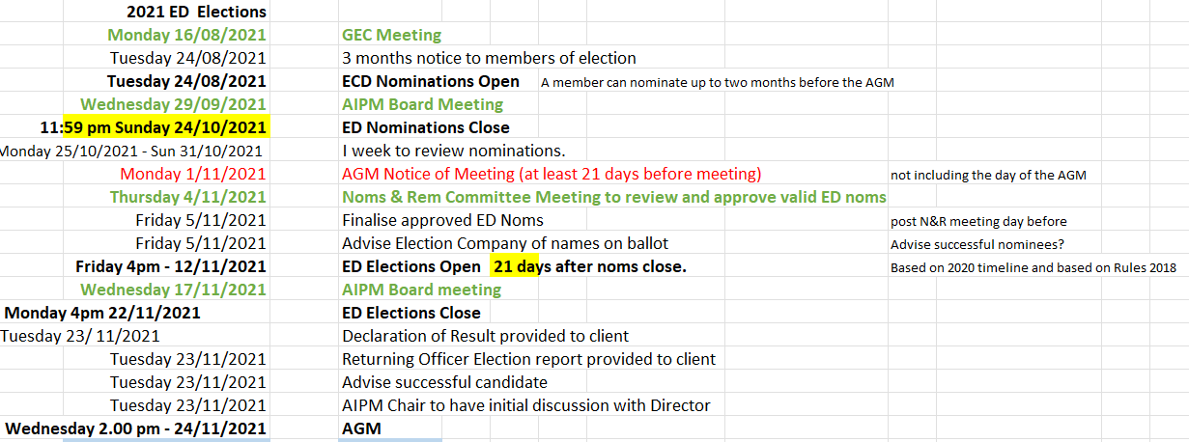

- Elected Director Notice of Election

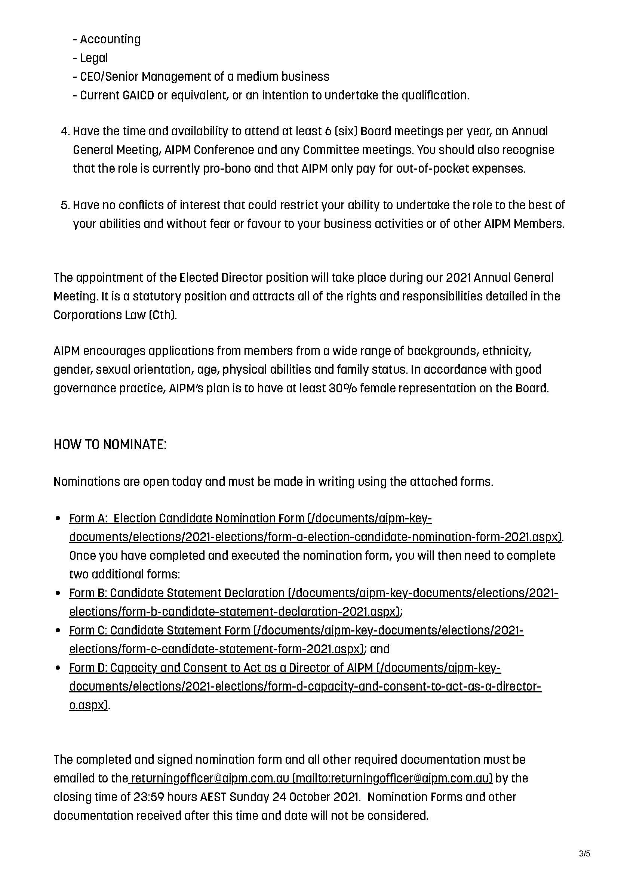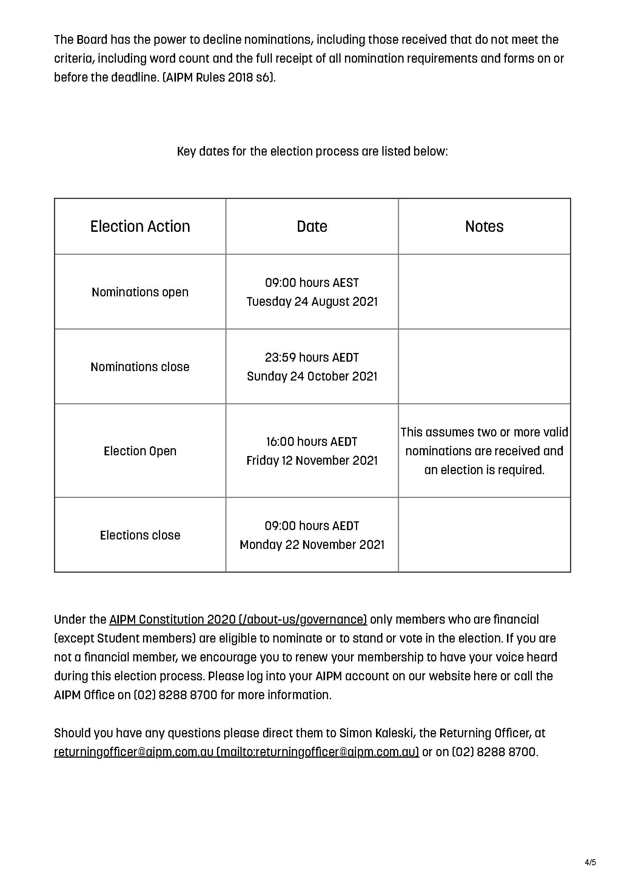

- Chapter Council Election Timetable

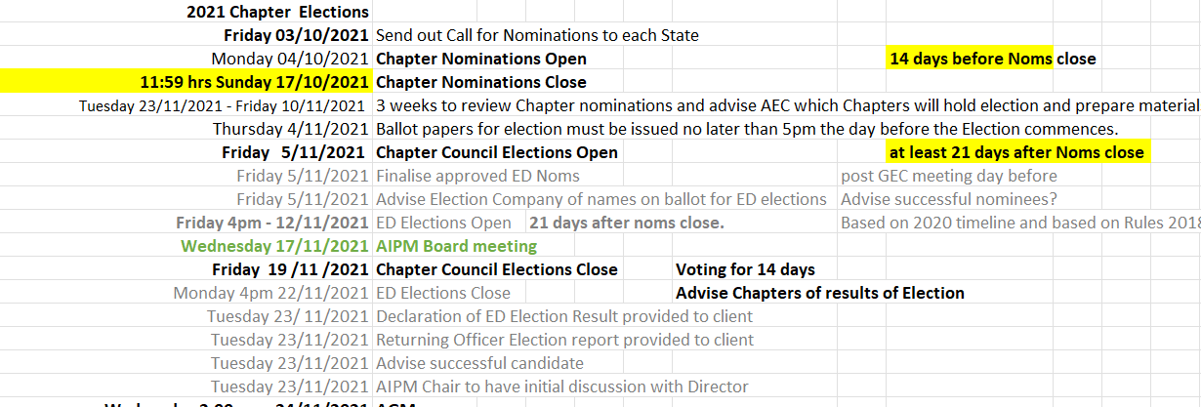

- Chapter Councils – Call for Nominations

